1. Assignment 2

**Description of problem:** Regular Expression to match the Indian Mobile Number

#10 Digit

#(The first digit will be [6-9]) and remaining 9 digits will be [0-9]

**Example**:- 9988774455(Valid)   5566332211(invalid)

#Re - ^[6-9][0-9]{9}

**Example**:- 09988774455

#(Re - ^[0][6-9][0-9]{9}Dollar)

**Example**:- +919988774455

#Re - ^[+][9][1][6-9][0-9]{9}

**Deliverable (s):** Regular Expression

**Format, Place, and Reference:** Regular Expression

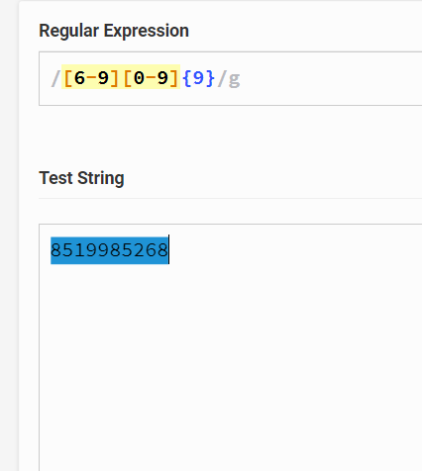

1. Assignment 3

**Description of problem:**Using regular Expression Create a Pattern

# To Validate Email Id

# Username @ DomainName .Extension

#Username -> ^[A-Z a-z][A-Z a-z 0-9]{5,15}

#Username Can be Pawankumar1234@gmail.com ,Anilkumar@dhyanahita.org

#Domain Name--[A-Z a-z]{2,10}

#Domain Name can be Gmail,ymail,hotmail,yahoo,outlook,live,org

#Extension--[A-Z a-z]{2,3}

#Extension name can be com in us org en

**Example:**

1. Pawankumar1234@gmail.com(Valid)
2. 18Pawankumar123@gmail.com(invalid)

**Deliverable (s):** Regex pal

**Format, Place, and Reference:** Regex pal

